Sprint 3 – Agility Design Document

April 18, 2022

Table of Contents

1. Executive Summary 3

1.1 Project Overview 3

1.2 Purpose and Scope of this Specification 3

2. Product/Service Description 3

2.1 Product Context 3

2.2 User Characteristics 3

2.3 Assumptions 3

2.4 Constraints 3

2.5 Dependencies 4

3. Requirements 4

3.1 Functional Requirements 5

3.2 Security 5

3.2.1 Protection 5

3.2.2 Authorization and Authentication 6

3.3 Portability 6

4. Requirements Confirmation/Stakeholder sign-off 6

5. System Design 6

5.1 Algorithm 6

5.2 System Flow 6

5.3 Software 6

5.4 Hardware 6

5.5 Test Plan 7

5.6 Task List/Gantt Chart 7

5.7 Staffing Plan 7

# Executive Summary

## Project Overview

This project’s goal is to program a Sphero robot to complete an agility sprint. The robot must successfully complete an obstacle course, avoid objects, go up a ramp, and knock over markers.

## Purpose and Scope of this Specification

It will start in the starting location. It will avoid 3 objects. It will go over a ramp. It will knock over as many markers as possible.

In scope

* Programming the Sphero robot to complete the agility sprint
* Programming the robot to follow the tape of the obstacle course

**Out of Scope**

* It won’t collide with anything

# Product/Service Description

Robot will start from the starting location. Robot will avoid 3 objects. Robot will go over a ramp. Robot will knock over as many markers as possible.

## Product Context

This project contains many interfaces. Sphero is used to create the block code, excel is used to create the Gantt chart, and Word is used to create the documents. It is Sprint 3 of a 3 Sprint project.

## User Characteristics

* Student
* Experience with coding
* Experience with a Sphero robot

## Assumptions

The room HH208 must be available to run the course. A Sphero robot is needed, the Sphero coding app is needed, and coding experience is needed. Must be able to record the robot.

## Constraints

Describe any items that will constrain the design options, including

* Room size
* Sphero coding
* Room availability

## Dependencies

* The project needs to be tested before recording it
* The code needs to be completed before testing it

# Requirements

The robot will start in the starting location. The robot will encounter 3 objects which it must avoid. The robot will go over the ramp. The robot will knock over as many pins as possible.

## Functional Requirements

|  |  |  |  |  |  |
| --- | --- | --- | --- | --- | --- |
| **Req#** | **Requirement** | **Comments** | **Priority** | **Date Rvwd** | **SME Reviewed / Approved** |
| ENDUR_01 | Start from the square | Starting location | 1 | 4-14-22 | Approved |
| ENDUR_02 | Stay in the path provided | Stay on the tape | 1 | 4-14-22 | Approved |
| ENDUR_03 | Avoid all objects | Go around bottles | 2 | 4-14-22 | Approved |
| ENDUR_04 | Speed up on path after last object | Stay on the tape | 1 | 4-14-22 | Approved |
| ENDUR_05 | Go over the ramp | Ride up and off ramp | 2 | 4-14-22 | Approved |
| ENDUR_06 | Hit the markers | Knock them over | 3 | 4-14-22 | Approved |

## Security

### Protection

* encryption
* activity logging, historical data sets
* restrictions on intermodule communications
* data integrity checks

### Authorization and Authentication

Verifies identity of user.

## Portability

* Code is on one computer, can be shared
* Cost of robot
* Robot battery
* Use of block code
* Sphero application

# Requirements Confirmation/Stakeholder sign-off

|  |  |  |
| --- | --- | --- |
| Meeting Date | Attendees (name and role) | Comments |
| 04/11/22 | Gianna Rao: Project Manager | confirmed all |
| 04/11/22 | Christopher Morandi: Functional Manager | confirmed all |

# System Design

## Algorithm

Code:

1. Start

2. Roll 0 degrees at 27 speed for 3.5 seconds

3. Roll 90 degrees at 27 speed for 3.8 seconds

4. Roll 0 degrees at 27 speed for 4.1 seconds

5. Roll 90 degrees at 128 speed for 2.5 seconds

6. Delay for 1 second

7. Roll 225 degrees at 128 speed for 4 seconds

8. Stop

Test the code and record the robot

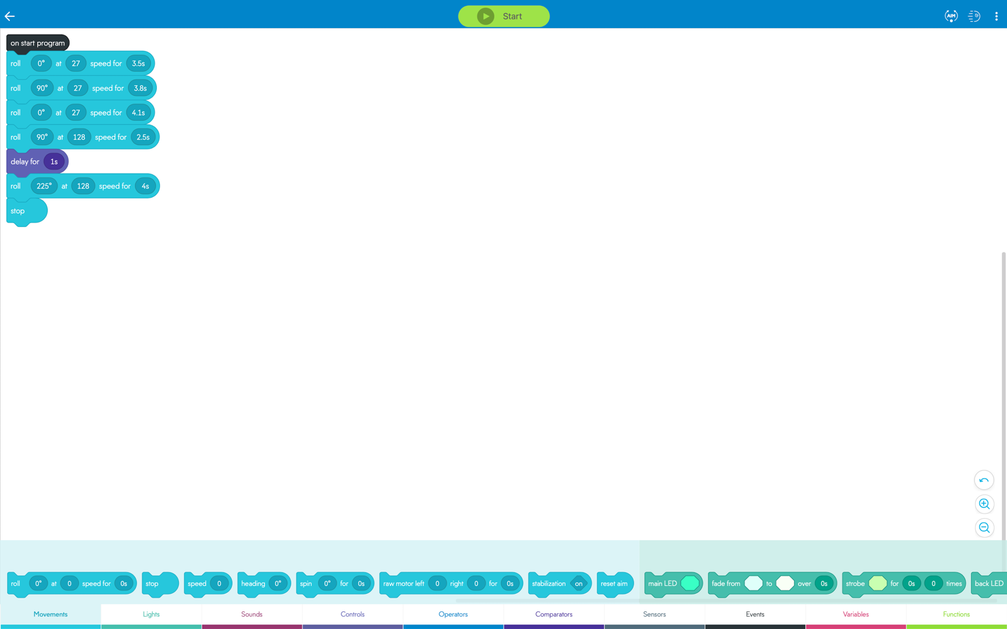

## System Flow

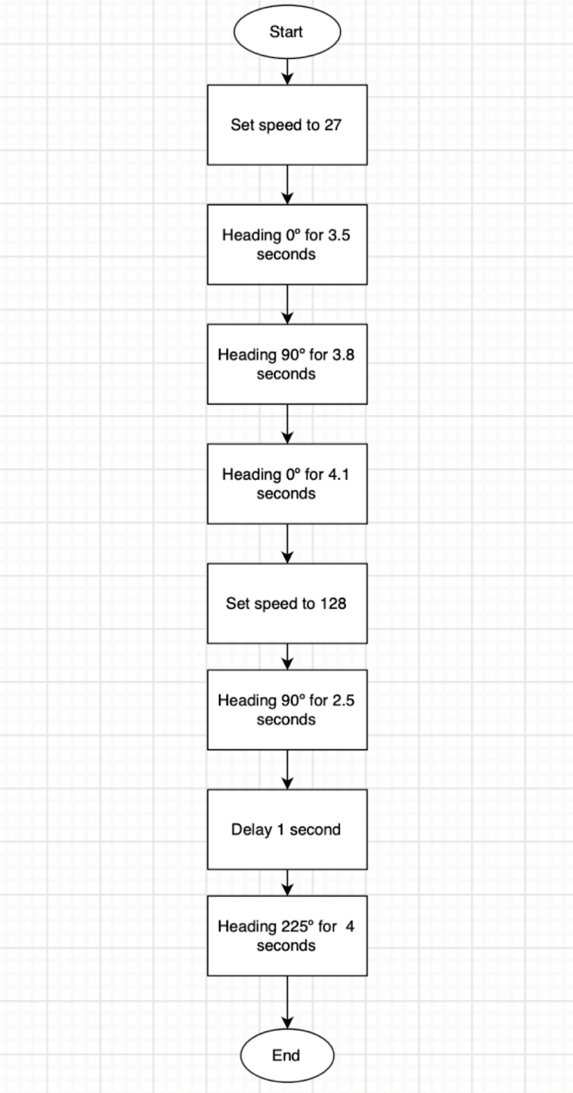

## Software

Sphero application and block code to program the Sphero robot.

## Hardware

MacBook Pro, iPhone to record, Sphero robot, room HH208’s course.

## Test Plan

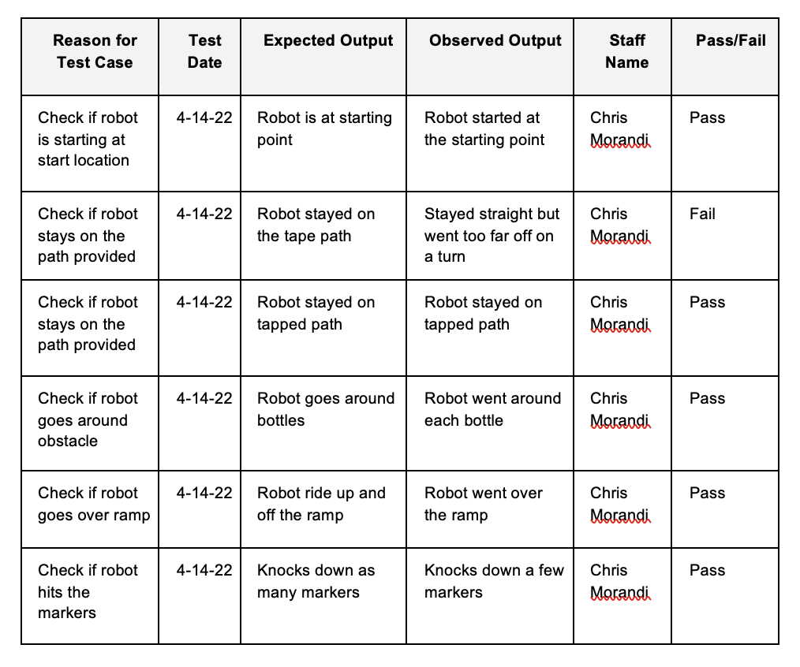

Sensor Data Diagram:

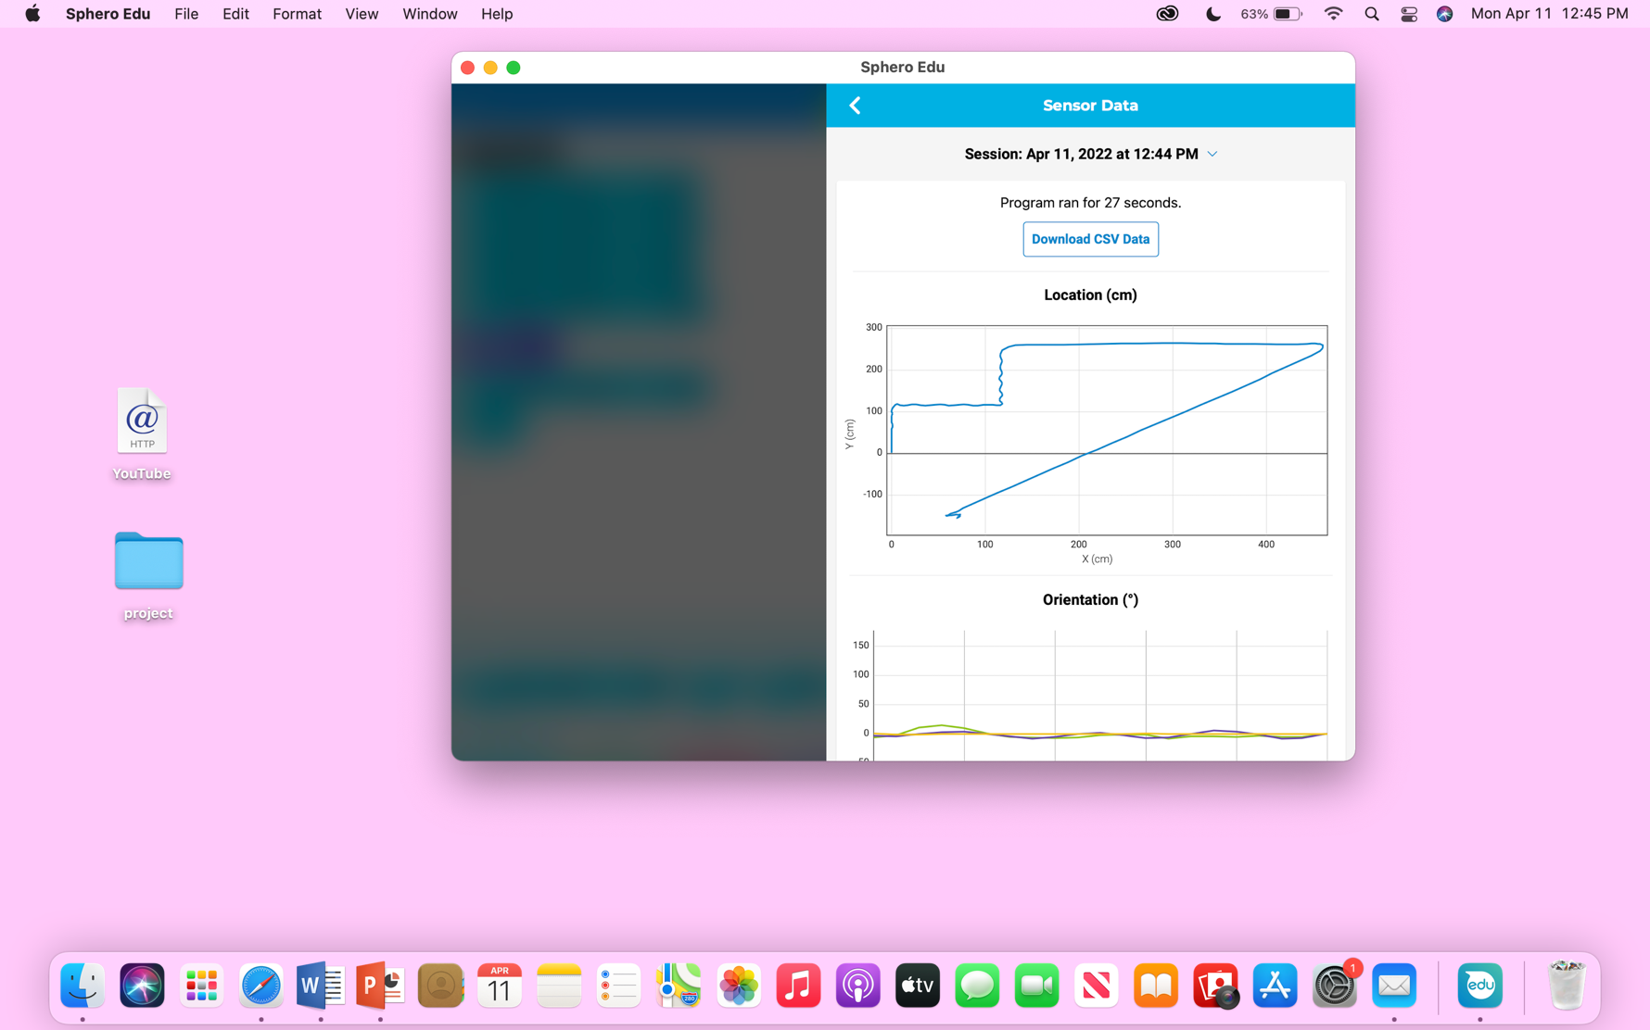

## Task List/Gantt Chart

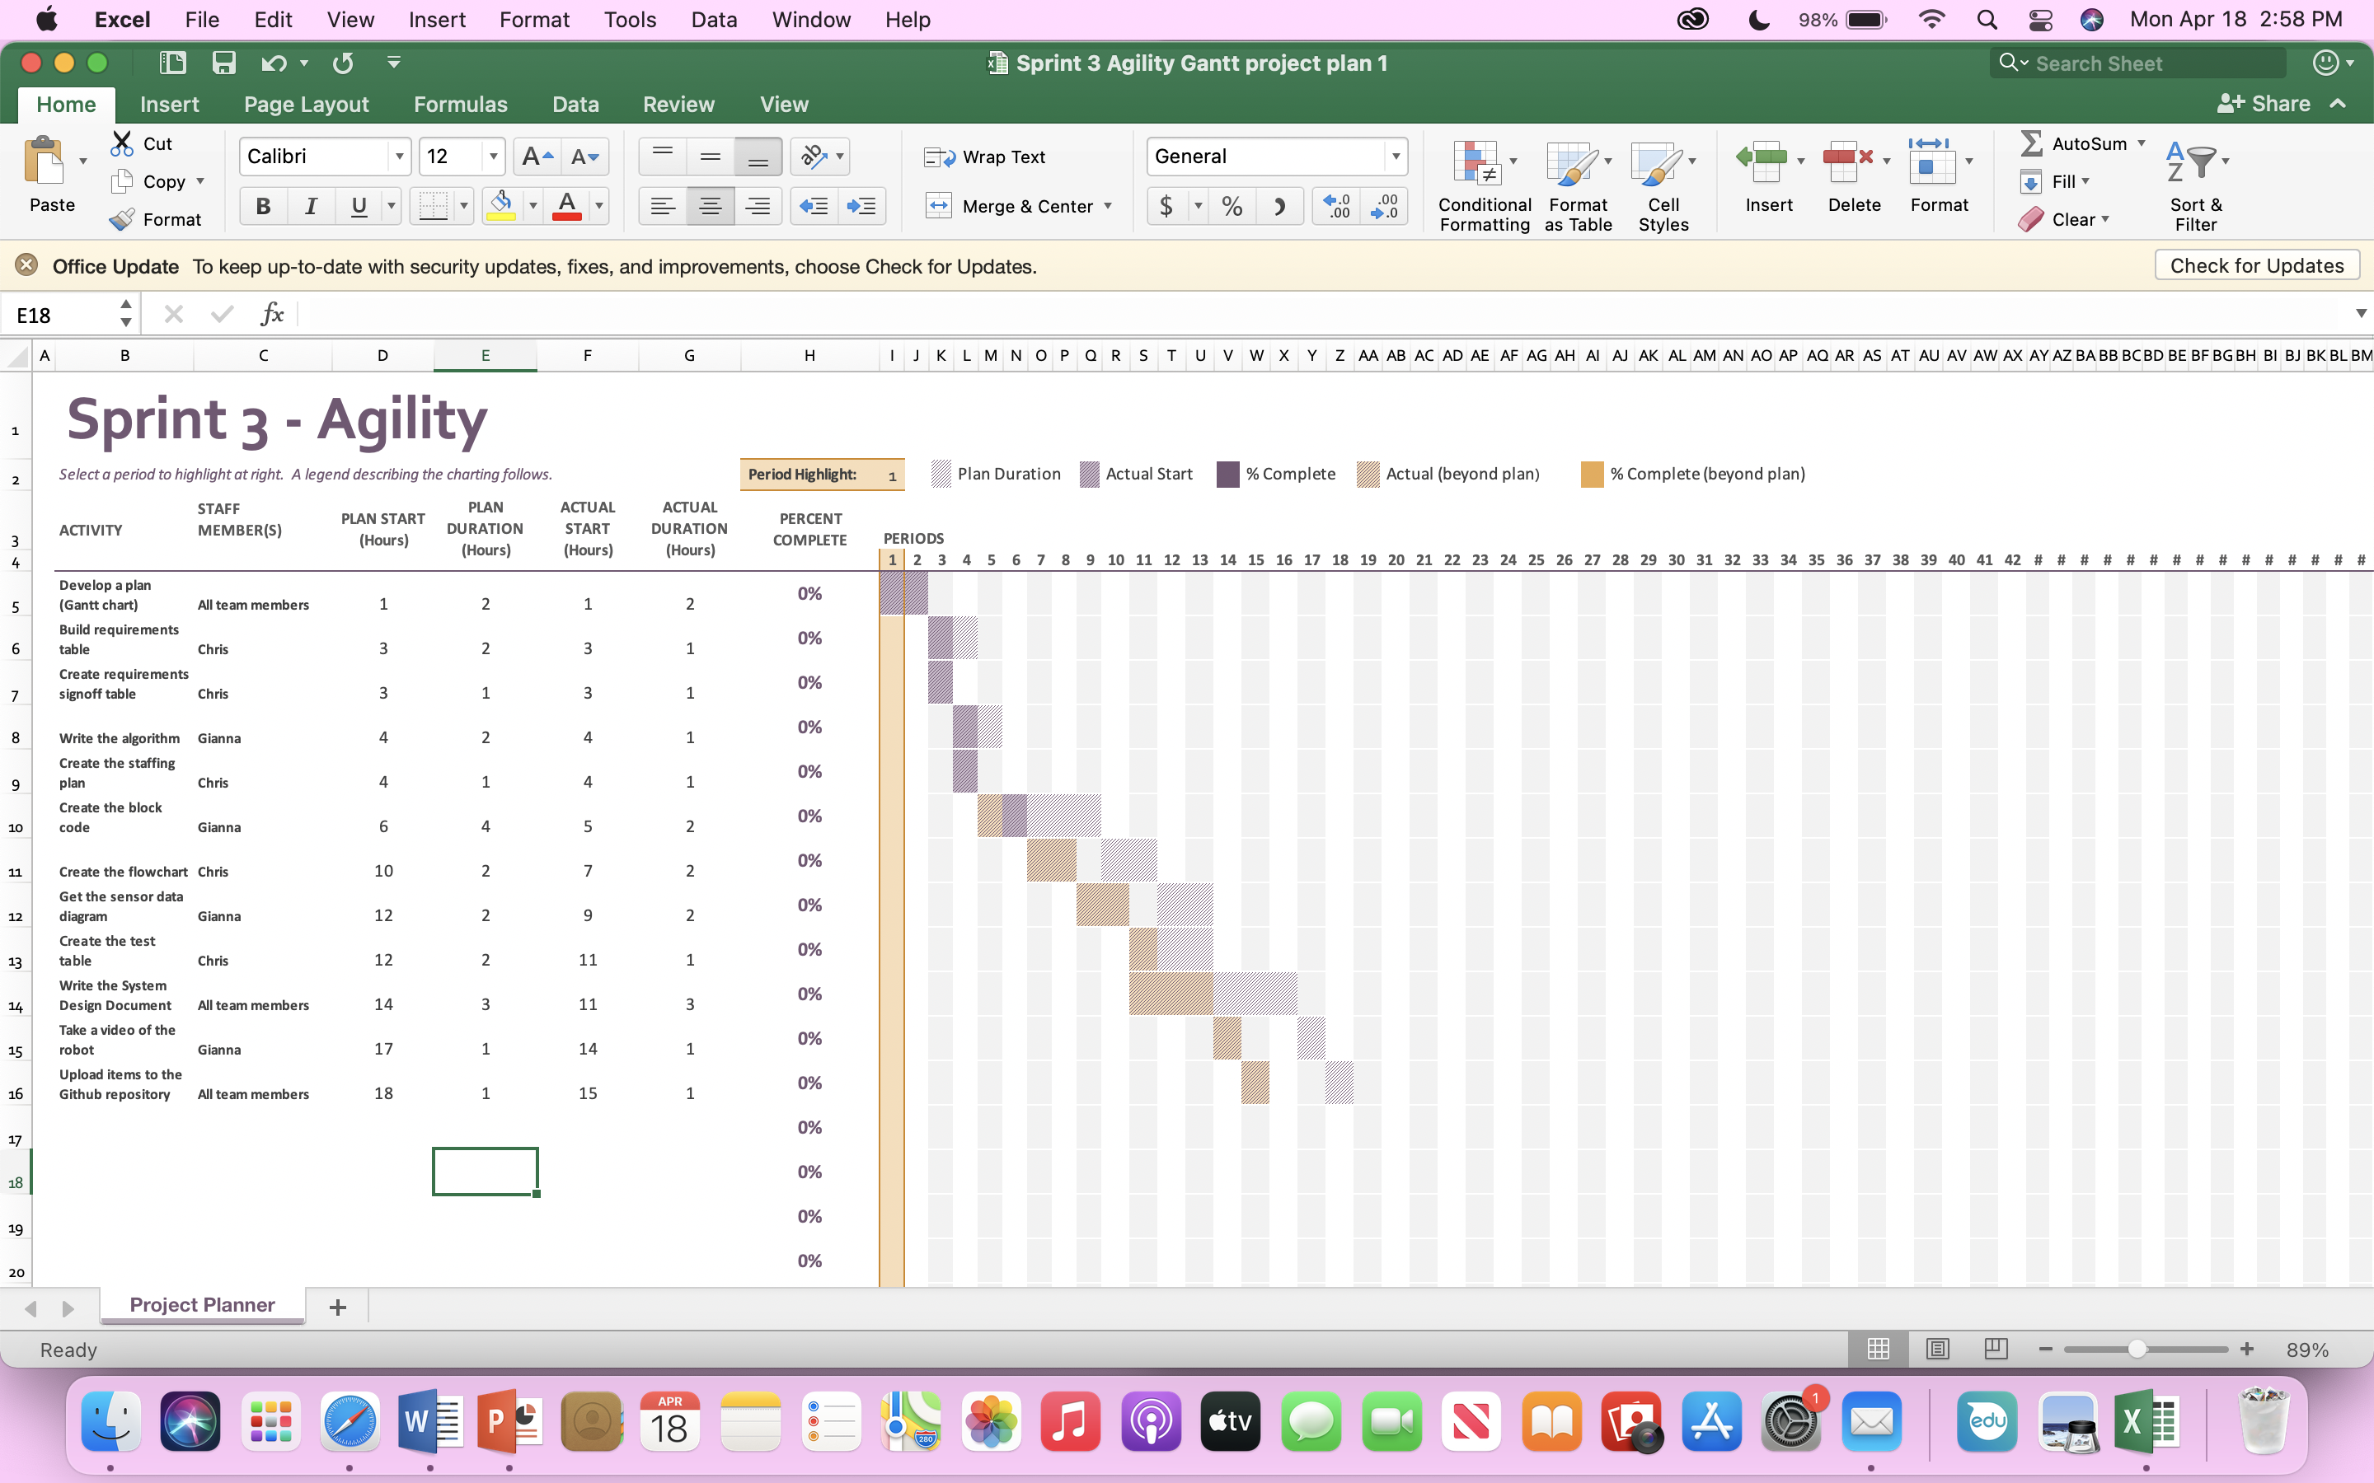

## Staffing Plan

| Name | Role | Responsibility | Reports To |
| --- | --- | --- | --- |
| Gianna Rao | Project Manager | Complete requirements of the project | Functional Manager |
| Christopher Morandi | Functional Manager | Make sure all requirements are completed | Project Manager |